**AI RECRUITING**

**Category :** Artificial Intelligence

**Skills Required :** Node.js, IBM Cloud, IBM Watson

# Team Name : Incredibles

**College : SRI VENKATEWSARA COLLEGE OF ENGINEERING**

**(TIRUPATI)**

**Team Members :**

1. Eshwar Nagaraj(Team Lead)
2. Mamidikomma Sunil Teja
3. Mallambakam Thangavelu
4. Potham Manikanta Reddy

**Table of Contents**

|  |  |  |
| --- | --- | --- |
| **S.No** | **Contents** | **Page N.O** |
| 1. | Introduction   * 1. Purpose   2. Overview | 1 |
| 2. | Literature Survey   * 1. Existing problem   2. Proposed solution | 2 |
| 3. | Theoritical Analysis   * 1. Block Diagram   2. Hardware / Software designing | 3 |
| 4. | Flowchart | 4 |
| 5. | Experimental Investigations | 4 |
| 6. | Result | 20 |
| 7. | Advantages and Disadvantages | 21 |
| 9. | Conclusion | 23 |
| 10. | Future Scope | 23 |
| 11. | Bibilography | 23 |
| 12. | Appendix (Source Code) | 23 |

1. **INTRODUCTION**

## Purpose

AI recruiting is often described as the largest tech-induced transformation that ever hit the talent acquisition industry, and it seems that the hype is growing every week. Do you want to know what it’s all about? Well, you are in luck, you’ve just found the ultimate guide to AI recruitment.

In this comprehensive guide, we will look into every aspect of artificial intelligence (AI) recruiting. Not just the benefits, but also the negative aspects, what you should consider, and how unconscious bias can affect your implementation. We aim to give you a nuanced/thorough picture of how AI recruiting works and why you as a hiring manager should consider implementing it.

So let's dig in.

## Overview

In summary, this project will :

* Create a Webpage to enter the information of the candidate for evaluating process.
  + - Create a chatbot skill in Watson Assistant.
    - Use Smart Document Understanding to build an enhanced Watson Discovery collection.
    - Create an IBM Cloud Functions web action that allows Watson Assistant to

post queries to Watson Discovery

* + - Create a flow in **Node-RED** and test the bot to check whether it is giving accurate results or not.

In this project, we use the typical customer care chatbot experience but instead of relying on predefined responses, our webpage will provide chatbot that can call out to other IBM Watson services for additional sources of information. In our case, it will be candidate manual that has been uploaded into Database.

In recent years, artificial intelligence software solutions have seen more and more adoption in a number of different areas. Businesses save hundreds of millions of dollars annually by deploying machine learning onto all sorts of tasks.

With many repetitive, time-consuming, and data-driven tasks, the recruiting sector is a business area with enormous potential for an AI-revolution.

The last major tech transformation within Human Resources was the entrance of applicant tracking systems (ATS). That meant a great boost of productivity for recruiting teams, but many believe that AI recruiting will multiply outcomes many times over.

# LITERATURE SURVEY

## Existing Problem

Now a days we have some of the techniques for recruiting the candidates but it is not sufficient for the present day situation. Present recruiting process doesn’t allow more candidates at a time.

The typical customer care chatbot can answer simple questions, such as locations and hours, directions, and may be even making appointments. When a question falls outside of the scope of the pre-determined question set, the option is typically to tell the customer the question is not valid or offer to speak to a real person.

## Proposed Solution

In this project, we will provide another option. If the candidate entered all details in the webpage, the chatbot will use the webhook feature of Watson Assistant to pass the question onto our Watson Discovery Service, which has been pre-loaded with the device’s database manual. So now, instead of “Would you like to speak to a company representative?” we can return relevant sections of the webpage to help the candidate recruiting problems.

To take it a step further, we will use the Smart Document Understanding (SDU) feature of Watson Discovery to train it on what text in the candidate manual is important and what is not. This will improve the answers returned from the queries.

**IWR Workflow**

IWR's cognitive tools all work together to solve real-life talent acquisition challenges for recruiters. Using these cognitive tools, recruiters can efficiently fill their requisitions with the best available candidates in less time.

Let's walk through an example of the IWR workflow. For example, a recruiter logs in to their ATS, and:

Views their open requisitions. They see that the requisition has a high Requisition Priority value. The High priority rating means it requires a high level of effort to successfully fill this position by the target date.

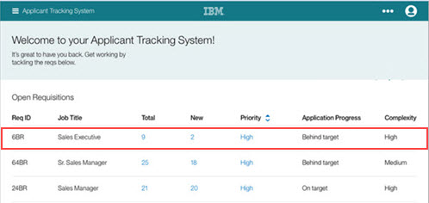

The header row for each requisition might be configured to display the following values for IWR: , Application progress, Title. Total candidates for the requisition, Req Priority, and Target Date. Clients can configure the column display.

**What is SDU?**

SDU trains Watson Discovery to extract custom fields in the documents. Customizing how the documents are indexed into Discovery will improve the answers returned from queries. With SDU, we annotate the fields within the documents to train custom conversion models. As we annotate, Watson is learning and will start predicting annotations. SDU models can also be exported and used on other collections.

# THEORITICAL ANALYSIS

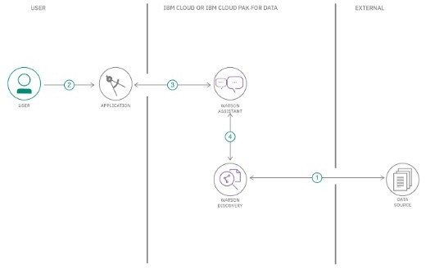**Block Diagram**

**Hardware / Software Designing**

Software Required : IBM Cloud, Node-RED, Db2, Watson assistant, Cloudant

* IBM Cloud offers the most open and secure public cloud for business, a next- generation hybrid multicloud platform, advanced data and AI capabilities, and deep enterprise expertise across 20 industries.
* Node-RED is a programming tool for wiring together hardware devices, APIs and online services in new and interesting ways. It provides a browser-based editor that makes it easy to wire together flows using the wide range of nodes in the palette that can be deployed to its runtime in a single-click. Javascript functions can be created within the editor using a rich text editor. The flows created in Node-RED are stored using JSON which can be easily imported and exported for sharing with others. Node-RED is built on Node.js
* IBM Db2® on Cloud is a transactional cloud database built for robust performance, providing a high-availability option with a 99.99% uptime service-level agreement (SLA). Scale up and down as needed to meet business demands, and leverage rolling security updates for peace of mind. Available on IBM Cloud™ and Amazon Web Services (AWS). IBM Cloud offers the most open and secure public cloud for business, a next- generation hybrid multicloud platform, advanced data and AI capabilities, and deep enterprise expertise across 20 industries.
* Watson Assistant is IBM’s AI product that lets you build, train, and deploy conversational interactions into any application, device or channel.Most chatbots try to mimic human interactions, which can frustrate users when a misunderstanding arises. Watson Assistant is more. It knows when to search for an answer  
  from a knowledge base, when to ask for clarity and when to direct users to a human. Watson Assistant can be deployed in any cloud or on-premises environment – meaning smarter AI is finally available wherever you need it.
* IBM Cloudant® is a distributed database that is optimized for handling heavy workloads that are typical of large, fast-growing web and mobile apps. Available as an SLA-backed, fully managed IBM Cloud™ service, Cloudant elastically scales throughput and storage independently.

Cloudant is also available as a downloadable on-premises installation. The API and powerful replication protocol are compatible with an open source ecosystem that includes Apache CouchDB, PouchDB and libraries for the most popular web and mobile development stacks.

# FLOWCHART

* The webpage is annotated using Node-Red and other IBM tools to develop in better way.
* This page will report the details into a document via Smart Document Understanding.
* If the candidate completes his job to entered into the webpage then the actual recruiting process starts via interview by the chatbot.
* The user interacts with the back-end server via the app UI. The front-end app UI is a chatbot that engages the user in a conversation.
* Dialog between the user and back-end server is coordinated using a Watson Assistant named as “NATASHA”.
* The IBM Cloud Functions action will query the Watson Discovery Service and return the results.

# 5.EXPERIMENTAL INVESTIGATIONS

## Step – 1 : Create IBM Cloud Services

Create the following services :

1. Watson Assistant
2. Node-Red
3. Cloudant
4. Db2

## Step – 2: Configure Watson Assistant

Launch the Watson Assistant tool and create a new dialog skill. Select the Use sample skill option as the starting point. This dialog skill contains all of the nodes needed to have a typical call centre conversation with a user.

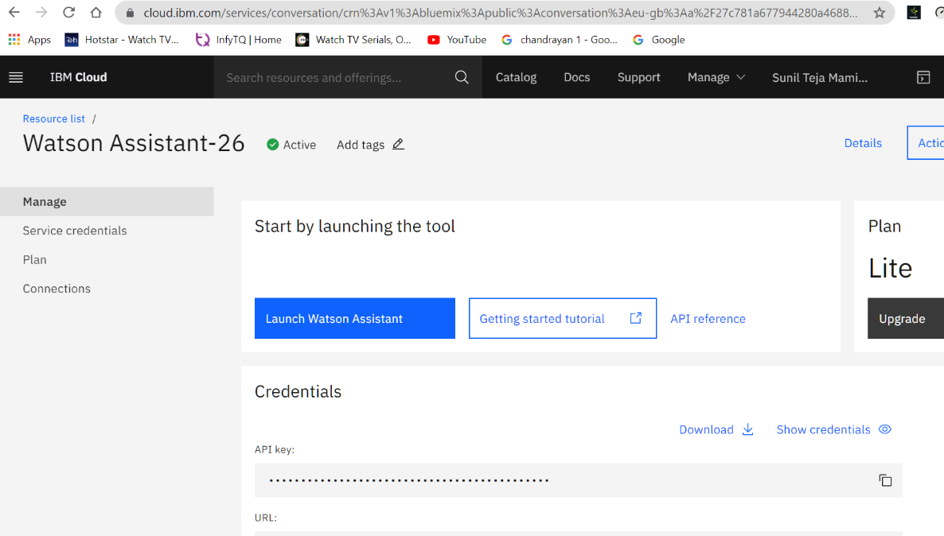

* Add new intent

The default AI recruiter dialog does not have a way to deal with any questions involving outside resources, so we will need to create a new intent that can detect when the user is ready to write the test.

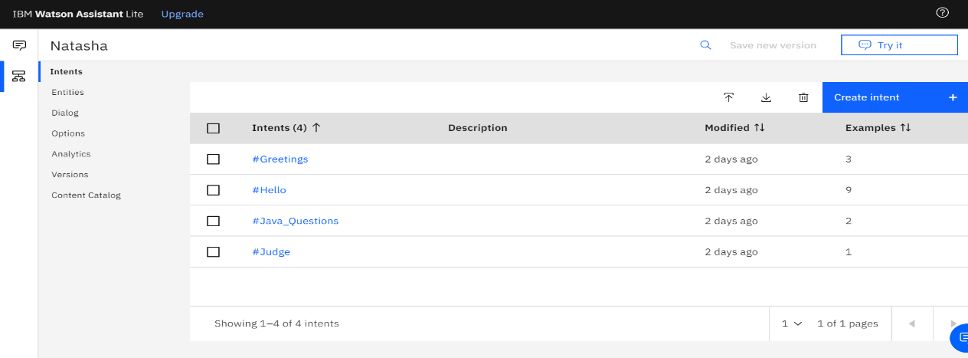

From the NATASHA Skill panel, select the Intents tab. Click the Create intent button. Name the intent #java_questions and enter the example questions to be associated with it.

* Create new dialog node

Now we need to add a node. Click on the **Dialog** tab, then search for “**Welcome**” node, and select the **Add node** below option.

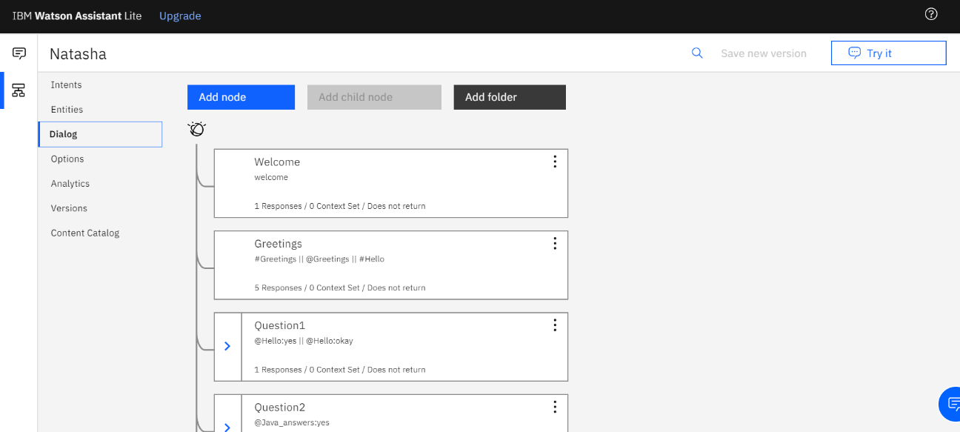

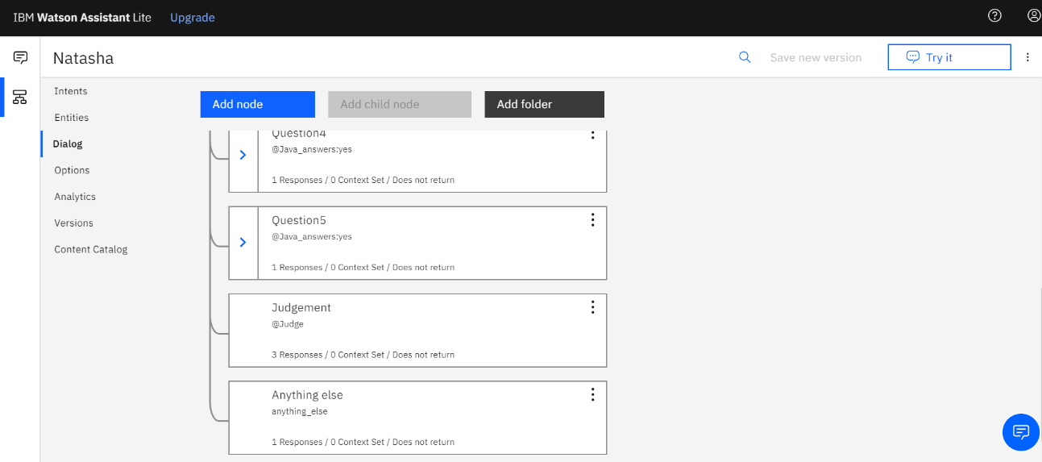

Optionally we can add the following responses to aid in debugging.

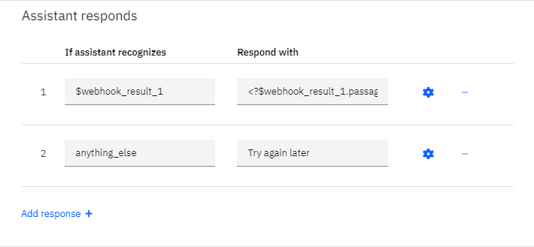

* Test in Assistant Tooling

From the Dialog panel, click the Try it button. Enter some user input:

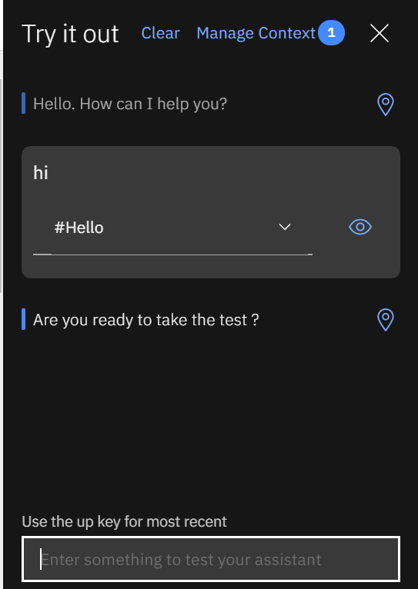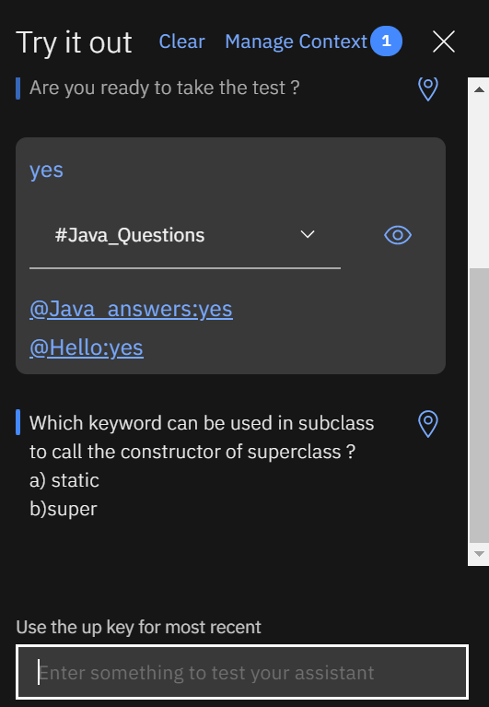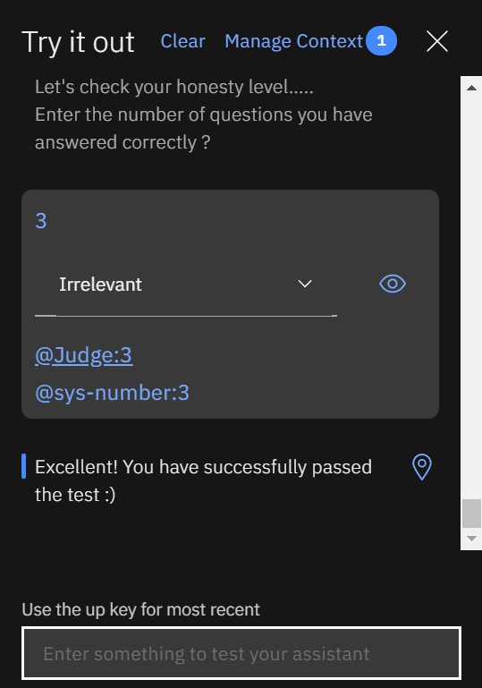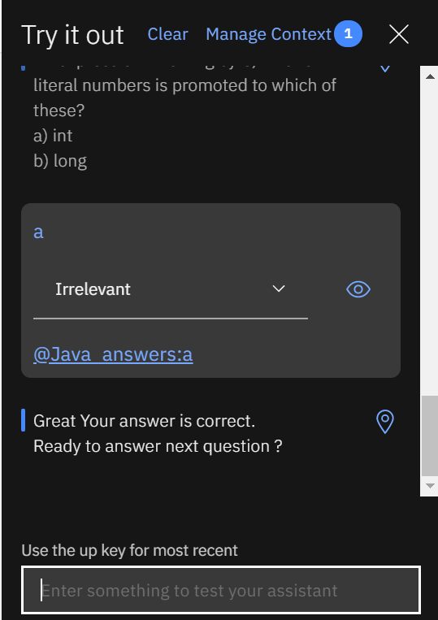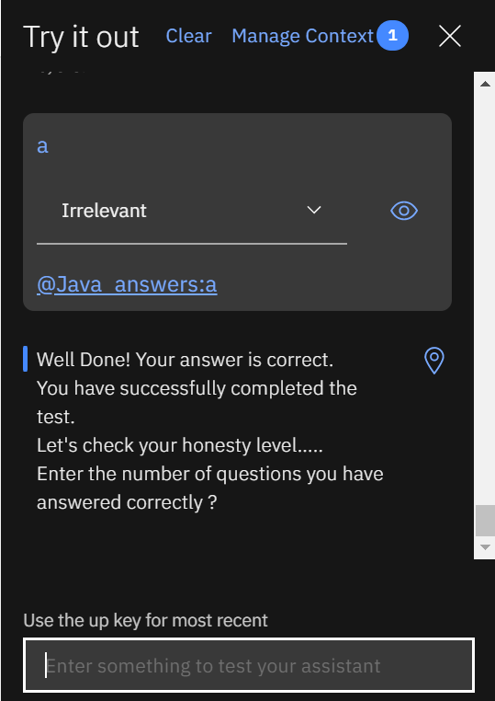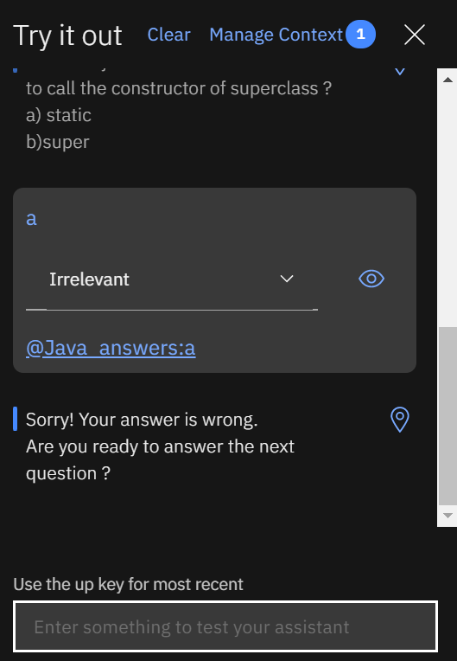

## Step – 3 : Create the Node-RED flow

First go to the **IBM Cloud dashboard** and Click on the **Resources list**, Go to **Cloud Foundary apps** and click on the app that we have created earlier. This will direct to the following page. There click on the **Visit App URL**.

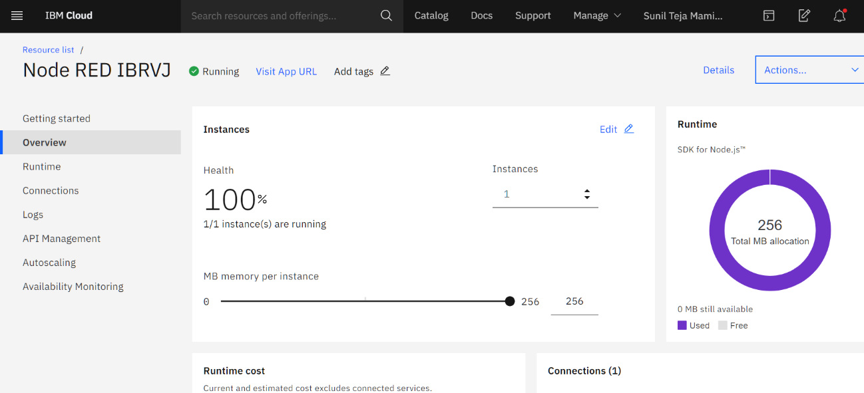

The first time we open the **Node-RED** app, we’ll need to configure it and set up security.

1. On the initial screen, click **Next** to continue.
2. Secure the Node-RED editor by providing a **username** and **password**. Click **Next** to continue.
3. The final screen summarizes the options we have made and highlights the environment variables. Click **Finish** to proceed.
4. From here, we can click **Go to your Node-RED flow editor** button to open the editor.

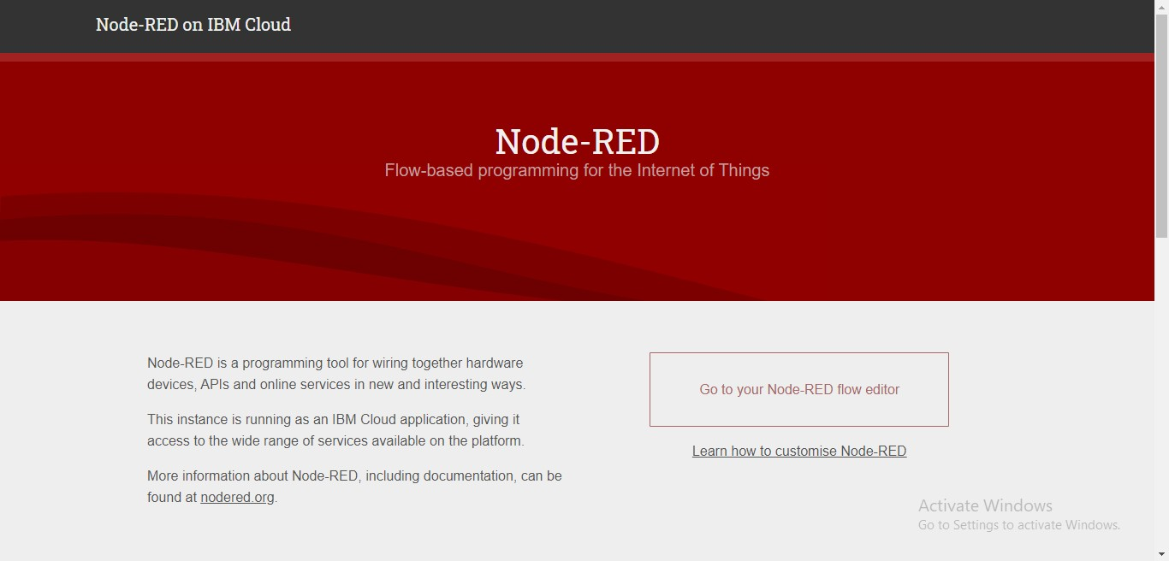

1. Now start creating the flow for this application as shown:

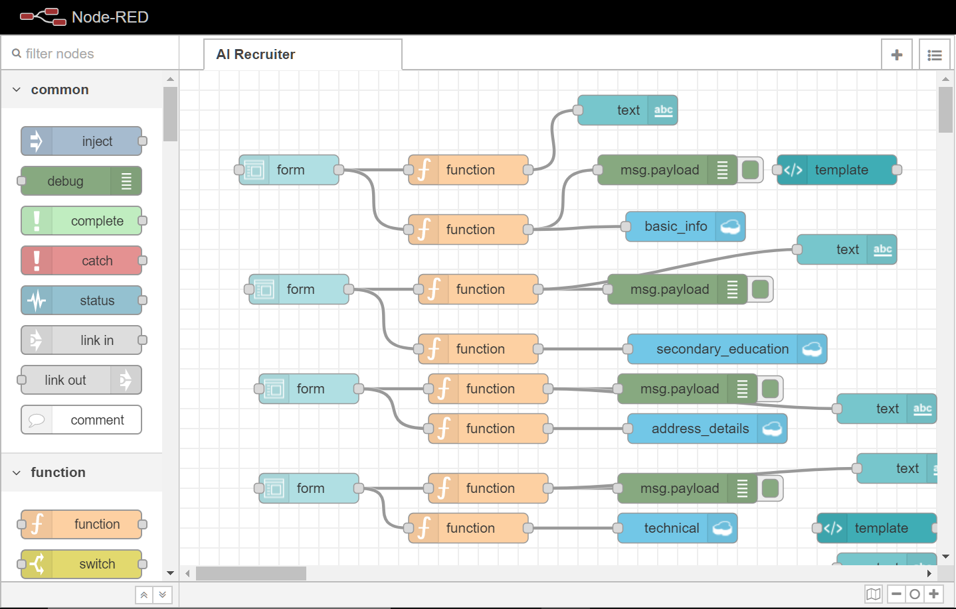

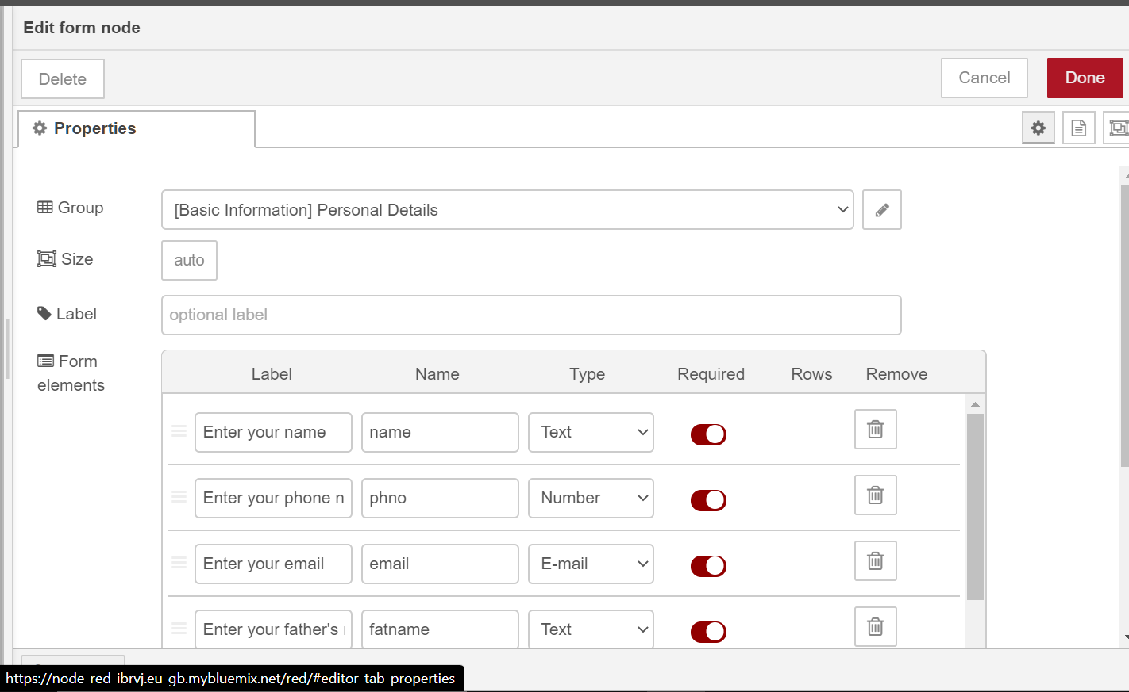

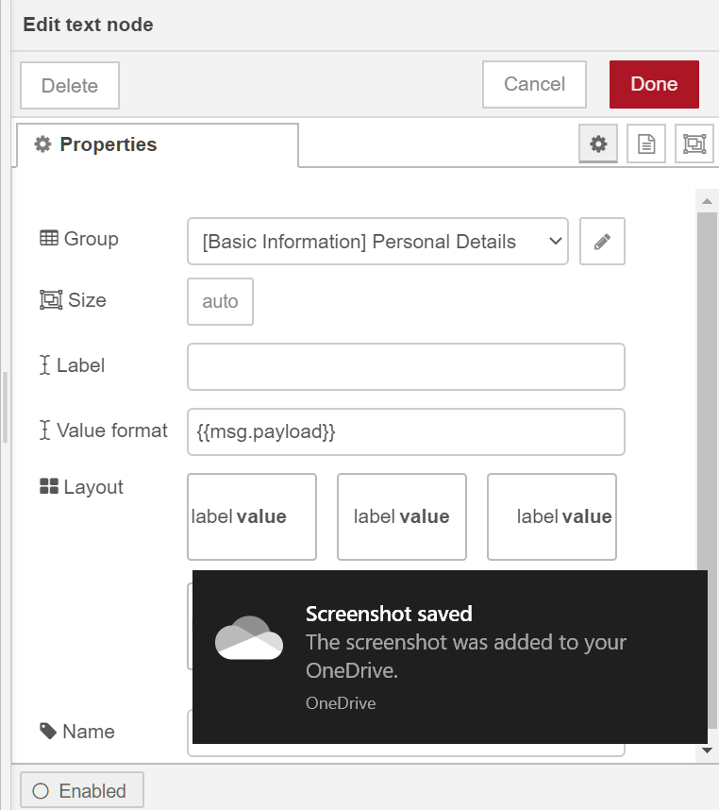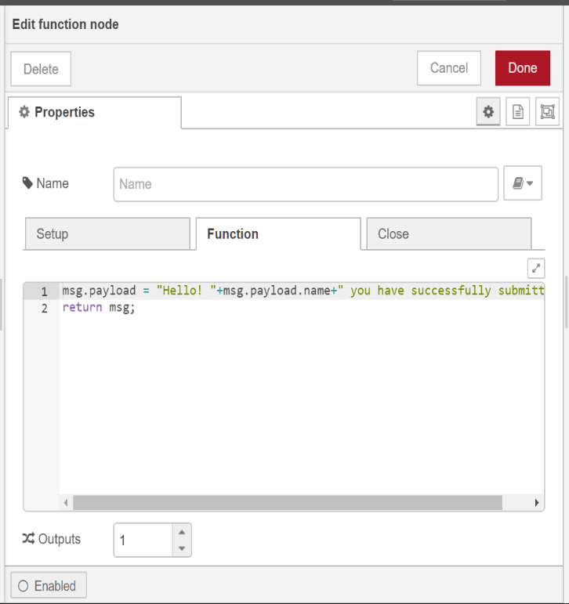

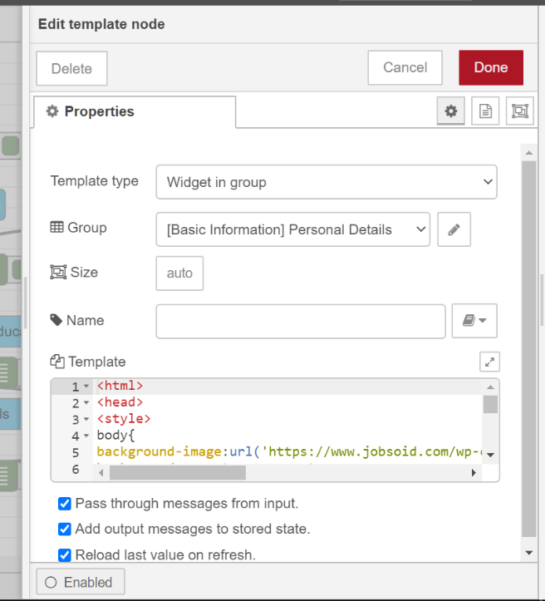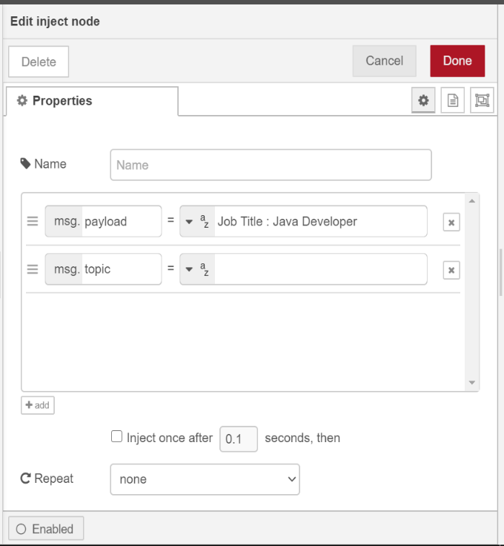

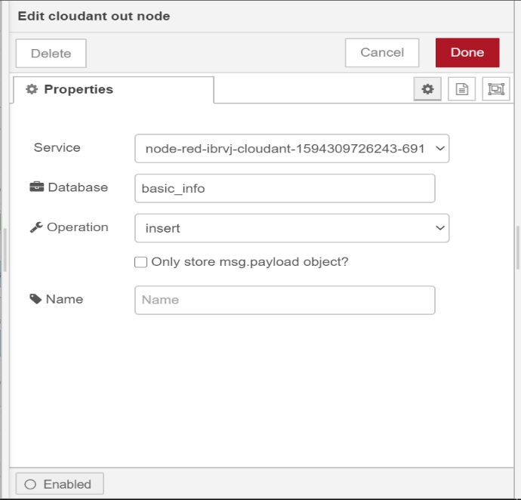

* For **parsing** function write the code as follows : msg.payload.text=""; if(msg.payload.context.webhook_result_1){

for(var i in msg.payload.context.webhook_result_1.results){

msg.payload.text=msg.payload.text+"\ n"+msg.payload.context.webhook_result_1.results[i].text;

}

msg.payload=msg.payload.text;

}

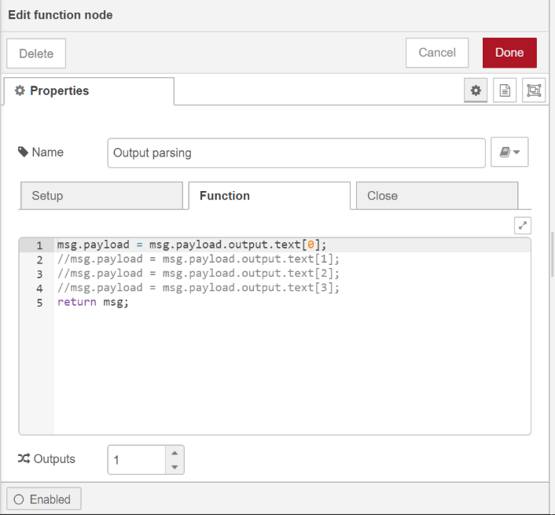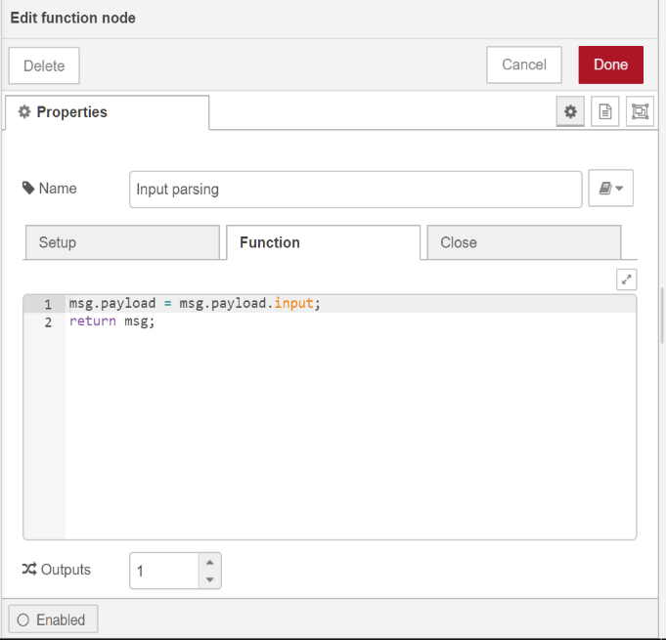else msg.payload=msg.payload.output.text[0]; return msg;

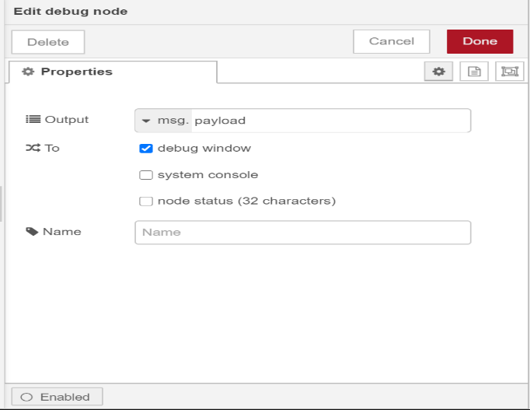

Configure the **Assistant** node with the **Workspace Id** ( We get it from **View API details** from Watson Assistant)(**Skill Id**). Make sure that you give the correct credentials. Otherwise it shows an error that **“Resource is not found”.** And make sure to **uncheck the save context** option in Assistance node.

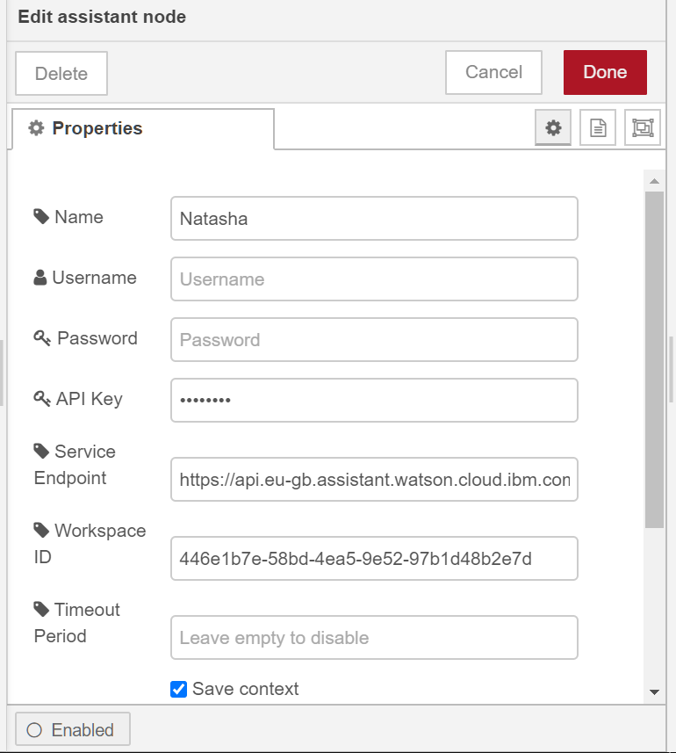

## Step – 4 : Create the Cloudant:

1. Log in to your IBM Cloud account.

The IBM Cloud dashboard can be found at: [**https://cloud.ibm.com/**](https://cloud.ibm.com/)**.** After you authenticate with your user name and password, you're presented with the IBM Cloud dashboard. Click the **create resource** button.

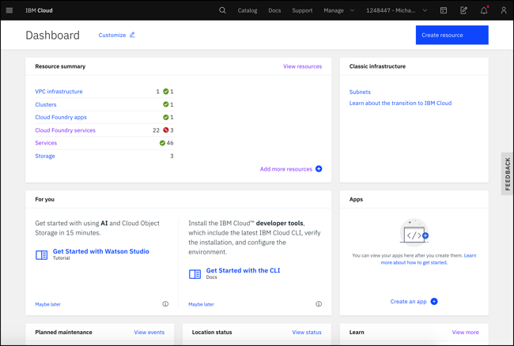Figure 1. IBM Cloud dashboard

1. Type **Cloudant** in the Search bar and click to open it:

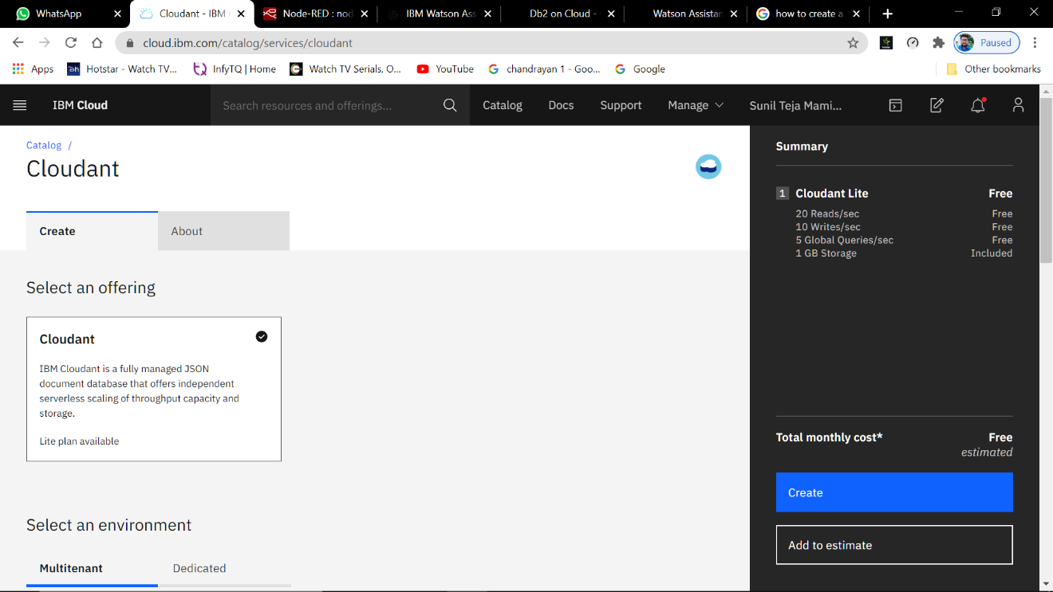Figure 2. IBM Cloud database services

1. In the service configuration window, select an offering and a region.

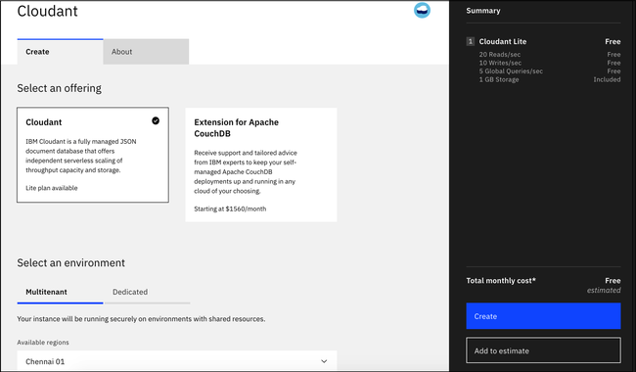Figure 3. IBM Cloudant region and pricing plan

1. Enter an instance name. (In this example, the instance name is **Cloudant-o7**. Verify that the resource group and authentication methods are correct. Add a tag if you like. The authentication methods that are available include **IAM or IAM and legacy credentials**. For more information, see [authentication methods](https://cloud.ibm.com/docs/Cloudant?topic=Cloudant-ibm-cloud-identity-and-access-management-iam-#ibm-cloud-identity-and-access-management-iam-). To create the service, click the **Create** button:

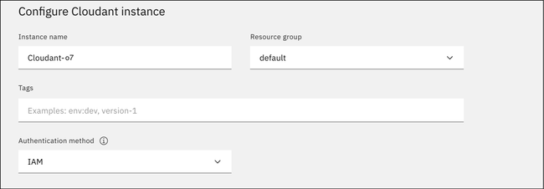Figure 4. IBM Cloudant service name and credentials

The IBM Cloudant team recommends that you use IAM access controls over IBM Cloudant legacy authentication whenever possible.

1. Select your pricing plan. (See the capacity in the table that follows.)

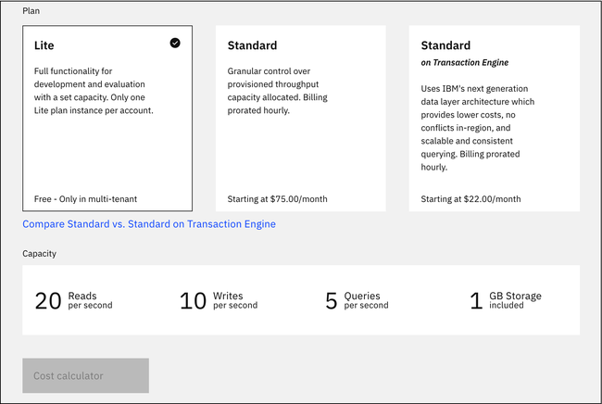Figure 5. Pricing plans and capacity

After you click Create, a message displays to say that the instance is being provisioned, which returns you to the Resource list. From the Resource list, you see the status for your instance is, "Provision in progress."

1. When the status changes to Active, click the instance, then click the**Service Credentials** tab to create the connection information that your application needs to connect to the instance.

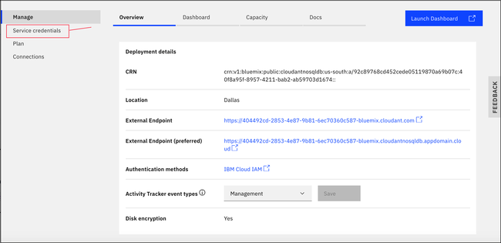Figure 6. Create IBM Cloudant service credentials

1. Create an IBM Cloudant service credential:

a. Click the **New credential** button.

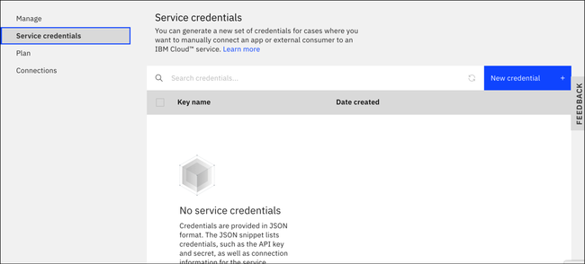Figure 7. Create new service credentials

b. Enter a name for the new credential in the Add new credential window. See Figure 8. Add a service credential.

c. Accept the Manager role.

d. (Optional) Create a service ID or have one automatically generated for you.

e. (Optional) Add inline configuration parameters. This parameter isn't used by IBM Cloudant service credentials, so ignore it.

f. Click the **Add**button.

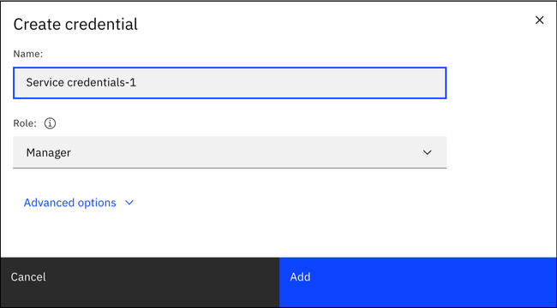Figure 8. Add a service credential

Your new credential appears after the table.

g. Click the chevron next to your credential.

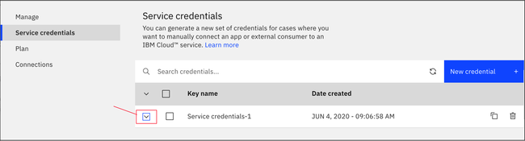Figure 9. View all service credentials

1. The details for the service credentials appear:

## The IBM Cloudant service credentials.

## Step – 5 : Create the Db2:

1. Log in to your IBM Cloud account.

The IBM Cloud dashboard can beound at: <https://cloud.ibm.com/>. After you authenticate with your user name and password, you're presented with the IBM Cloud dashboard. Click the **Create resource** button.

1. 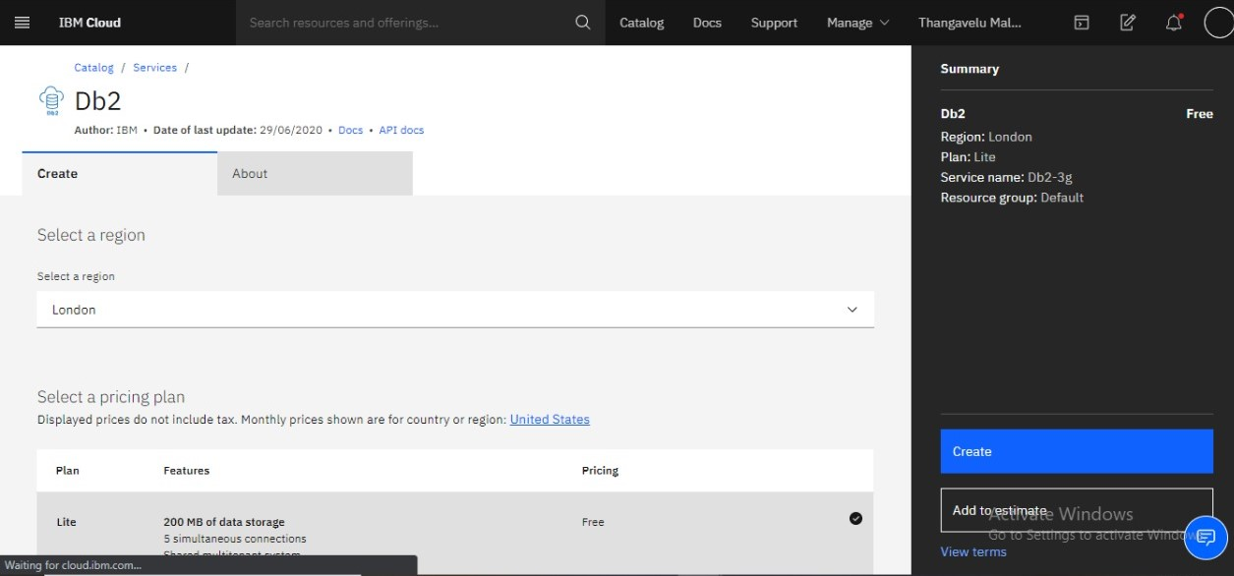Type **db2** in the Search bar and click to open it:
2. 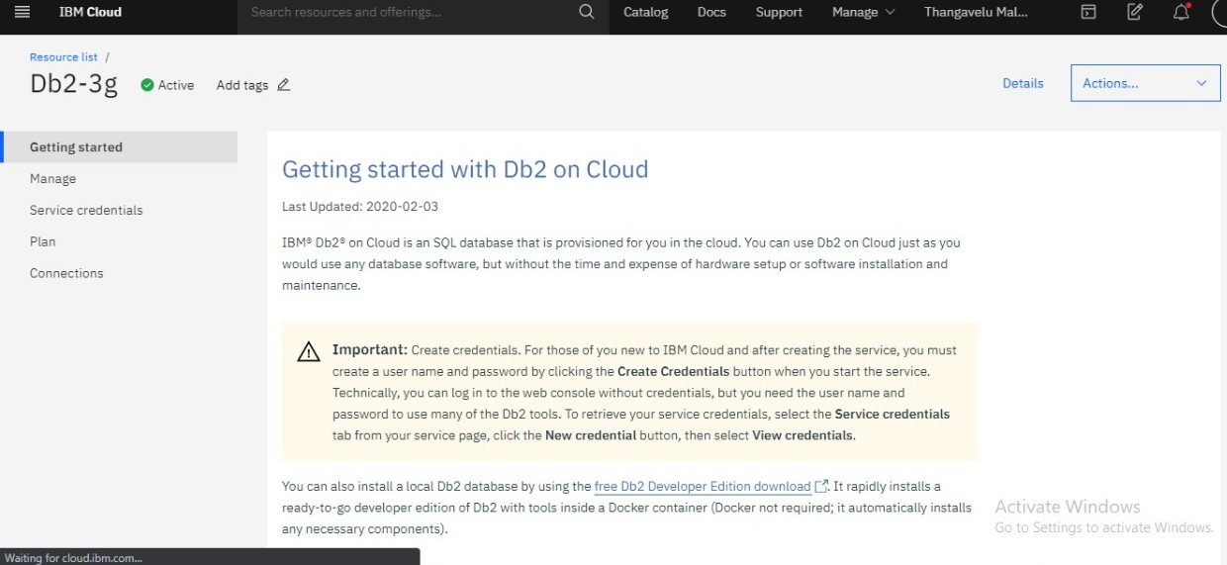Click on create button
3. Your Db2 is created manage by click on **open console.**
4. 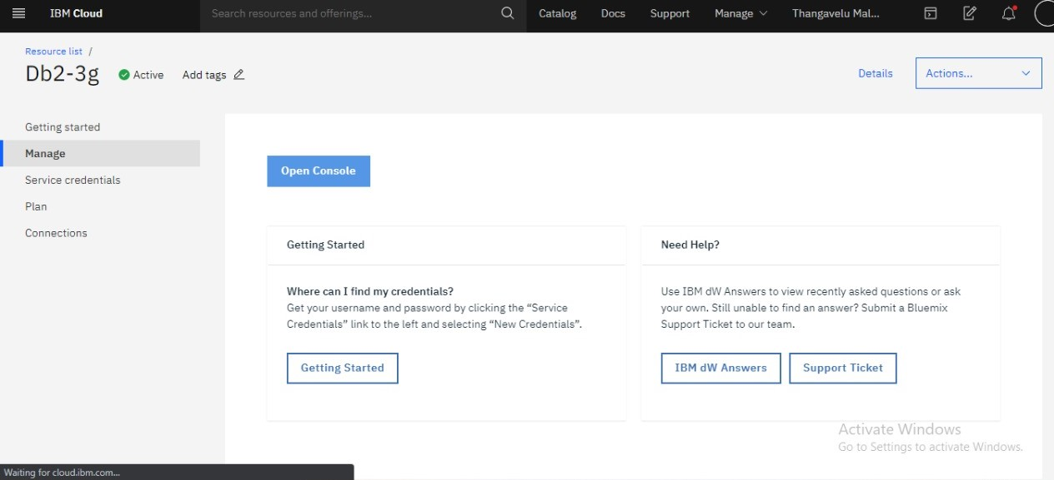Select the correct schema which you have created.

## 

## Create the tables which you want to display in the page.

## 

# RESULT

Now Click on the **Deploy** button. If you configure everything correctly, then you should see the following image saying that **“Successfully deployed”**.

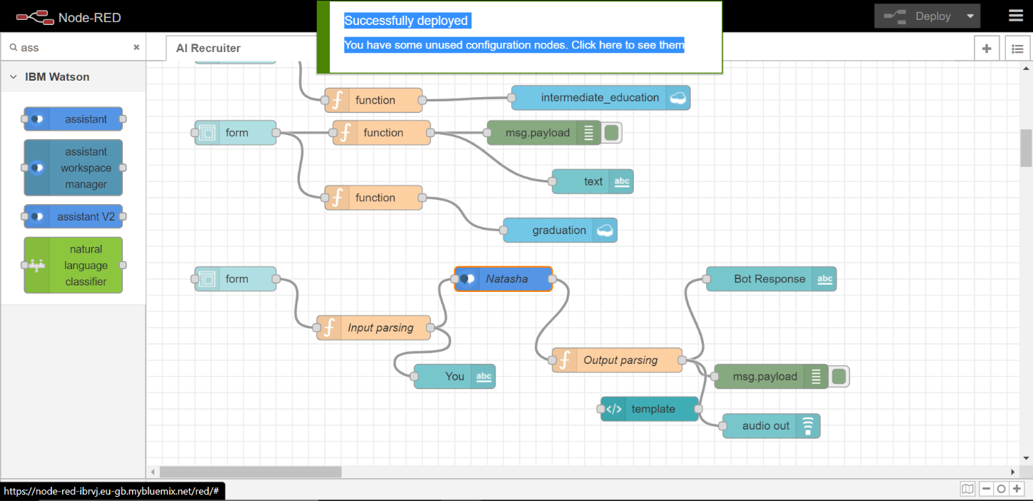

Now copy the URL till **.net/** and go to the new tab in browser and paste the URL and add **ui** at the last of the URL. You should see the following page. Enter some user inputs and test the bot and check whether it is giving accurate results or not.

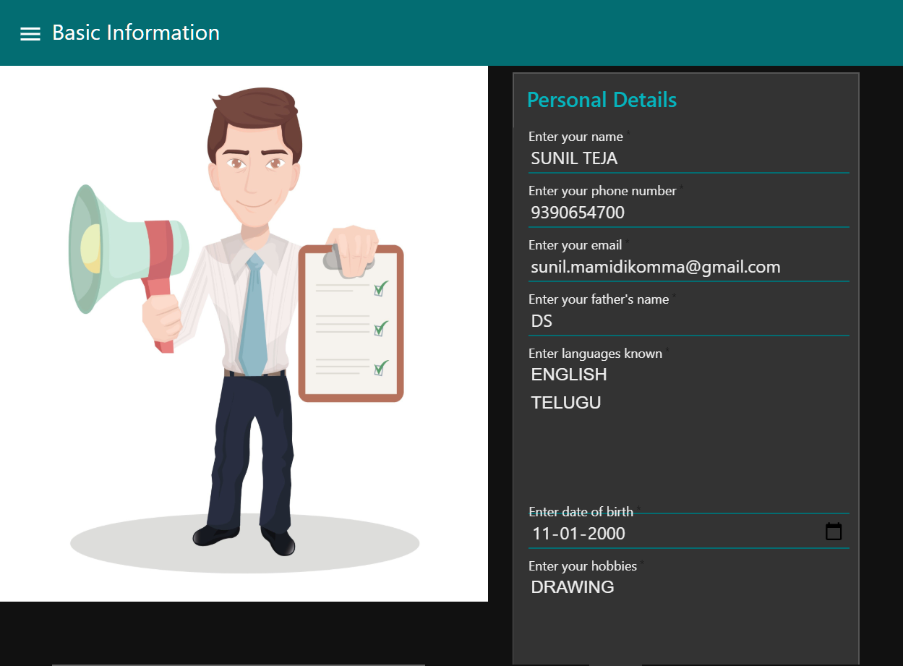

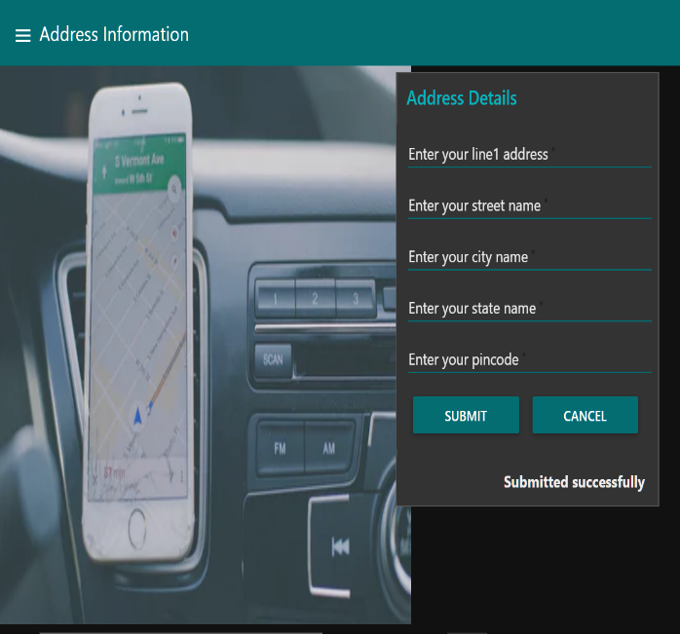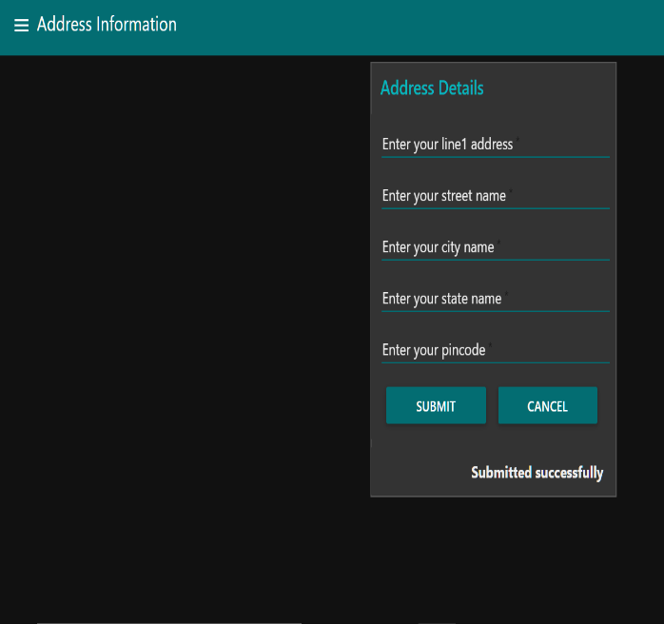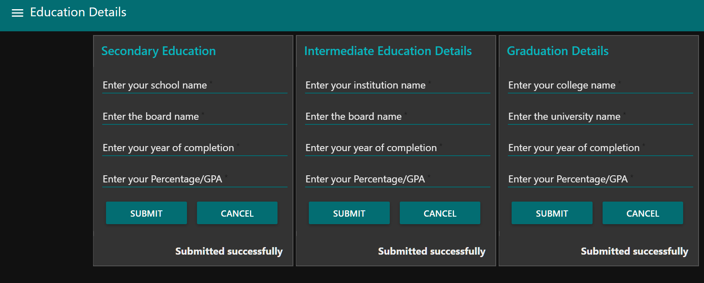

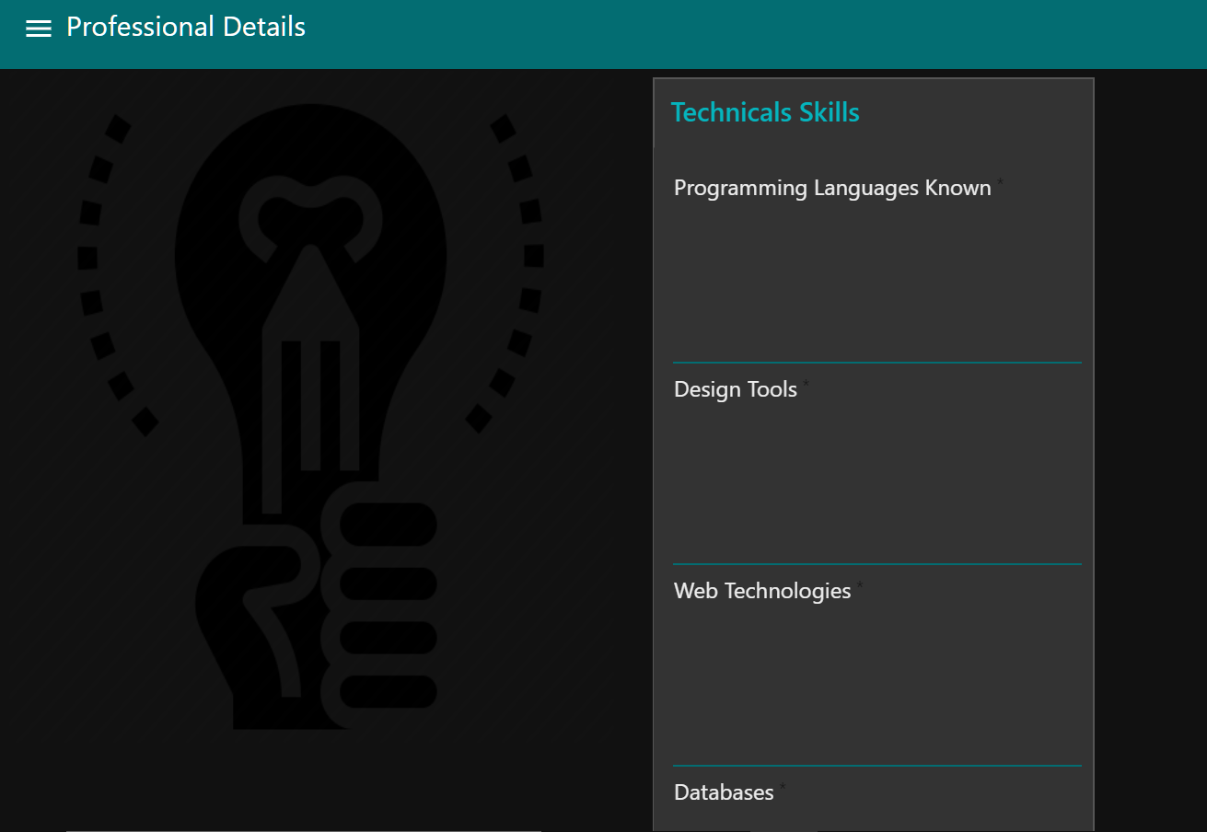

# 

# ADVANTAGES & DISADVANTAGES

# Advantages:

1. Reduce human biasness

Humans tend to be biased in some ways. Whether they realised it or not, some recruiters may make hiring decisions based on gender, ethnicity, age, looks and so on. An AI on the other hand, can be programmed to focus only on important factors such as candidates’ personality, skills, experience and qualifications.

1. Saves time, money and increase in efficiency

One of the main challenges for HR recruiters is to identify the best talent out of the many applications they receive each day. AIs can help to eliminate these manual tasks as they are programmed to obtain maximum efficiency in terms of time, costs and quality. Once the process of selecting candidates are fully automated, more data can then be gathered and efficiently assessed.

3. Improve candidate experience and engagement

HR recruiters are often inundated with tasks that take up most of their time, hence many face difficulties in maintaining good response time with their candidates, resulting in [poor candidate experience](https://www.jobstreet.com.sg/en/cms/employer/impact-bad-candidate-experience-overcome/?icmpid=hirerzone:prosncons_ai:20180411) and engagement. By introducing chatbots and virtual assistants, candidates will experience better interaction and response time, keeping them engaged and posted throughout the whole recruitment process.

**Disadvantages:**

1. Issues with accuracy and reliability

Although AI has come a long way, it is still far from being considered perfect. One of the major faults of applicant tracking system is that it lacks accuracy and reliability as it can easily be confused by formatting options. For example, an applicant might have all the good qualities that a recruiter seeks, but still fail to qualify into the AI’s list due to some unorthodox style of bullet points used in the application or resume.

2. Too much dependency on certain keywords

AI depends very much on certain keywords to scan through their pile of candidates. This can become a loophole for candidates who are familiar with how the system in AI is programmed, where they may include certain keywords that have the potential to trick the system and camouflage them as good fits for various positions, even though they are not.

3. Lacks nuance of human judgement

If a company is looking to diversify its workforce, using an AI in its hiring process may not be the best option. There are candidates out there who have atypical work experience but may still be the best fit for the position based on his or her personality, personal interests, character and work ethics. These are factors that require human judgement. Using an AI in this sense can greatly reduce the diversity in a workforce.

# CONCLUSION

Digital tools have been a big help to keep work going in this unprecedented, global crisis. And in many ways there’s reason to believe that this will speed up technology adoption. As people are forced into using tech in their daily work-life, we believe this will be an eye-opening event with a profound impact on work-life post Corona.

Remote working is one thing that likely will continue to see a much higher use even after things cool down. People realize that remote meetings work pretty well.

1. Improved Quality of Candidates

2. Automate Tedious Manual Tasks

3. Better Experience for Candidates  
4. An optimized Recruitment Process  
5. Cost Effective Hiring  
6. Reduced Time to Hire  
7. No more ‘talent waste’

To avoid face to face communication during pandemic situations

To get high accuracy in finding suitable candidate

To overcome situation like living in a remote location

To manage recruitment time and cost

# FUTURE SCOPE

Artificial intelligence in recruitment can significantly improve candidate engagement through improved communication between candidates and employers. According to Mya, a product developed to make recruiting simpler for businesses, its system has averaged “a 9.8 out of ten on overall candidate experience”.

AI can help with sourcing in a number of ways. For example:

Parse and search LinkedIn, Facebook and many other platforms to find qualified candidates with the right background.Sending personalized outreach emails.Easier rank matching candidates (hard with boolean search).Predict the likelihood of a candidate to make a move.The current crisis is horrible for everyone. People are dying, economies are shutting down and employees are being laid off their jobs. But crisis is also the mother of all innovation.

# BIBILOGRAPHY

1. <https://developer.ibm.com/recipes/tutorials/how-to-create-a-watson-chatbot-on-nodered/>
2. [https://developer.ibm.com/components/node-red/tutorials/how-to-create-a-node-red- starter-application/](https://developer.ibm.com/components/node-red/tutorials/how-to-create-a-node-red-starter-application/)
3. <https://www.ibm.com/cloud/get-started>
4. <https://www.ibm.com/watson/products-services>
5. [https://developer.ibm.com/components/watson-assistant/series/learning-path-watson- assistant](https://developer.ibm.com/components/watson-assistant/series/learning-path-watson-assistant)

# APPENDIX

## Source Code :

**Assistant Skills Source code:**

<https://github.com/SmartPracticeschool/SBSPS-Challenge-1165-AI-Recruiter---Shortlist-a-Suitable-Candidate-for-Specific-Job-Role/tree/master/Assistant_Skills>

Node Red flow Source code:

<https://github.com/SmartPracticeschool/SBSPS-Challenge-1165-AI-Recruiter---Shortlist-a-Suitable-Candidate-for-Specific-Job-Role/tree/master/NODE-RED%20flow>

**Discovery Dataset -** [https://github.com/SmartPracticeschool/llSPS-INT-870-Intelligent-Customer-](https://github.com/SmartPracticeschool/llSPS-INT-870-Intelligent-Customer-Help-Desk-with-Smart-Document-Understanding/tree/master/Discovery%20Dataset) [Help-Desk-with-Smart-Document-Understanding/tree/master/Discovery%20Dataset](https://github.com/SmartPracticeschool/llSPS-INT-870-Intelligent-Customer-Help-Desk-with-Smart-Document-Understanding/tree/master/Discovery%20Dataset)

**GitHub Account -** [https://github.com/SmartPracticeschool/llSPS-INT-870-Intelligent-Customer-](https://github.com/SmartPracticeschool/llSPS-INT-870-Intelligent-Customer-Help-Desk-with-Smart-Document-Understanding) [Help-Desk-with-Smart-Document-Understanding](https://github.com/SmartPracticeschool/llSPS-INT-870-Intelligent-Customer-Help-Desk-with-Smart-Document-Understanding)

**Node-RED flow link -** [https://ishubot.eu-gb.mybluemix.net/red/#flow/7764455e.d3d65c](https://ishubot.eu-gb.mybluemix.net/red/%23flow/7764455e.d3d65c)

**Node-RED UI link -** [https://ishubot.eu-gb.mybluemix.net/ui/#!/0?socketid=ofDza2eEa-](https://ishubot.eu-gb.mybluemix.net/ui/%23!/0?socketid=ofDza2eEa-D9GUboAAAB) [D9GUboAAAB](https://ishubot.eu-gb.mybluemix.net/ui/%23!/0?socketid=ofDza2eEa-D9GUboAAAB)